Customer Churn Prediction Using an Artificial Neural Network
Defined Architecture of the ANN Model
Stage 3, Deliverable 3-1(a) | Data Analyst, Predictive Modeling | October 2026

1. Purpose
This document defines the architecture of the Artificial Neural Network (ANN) built to predict whether a telecommunications customer will churn. It describes the input data, the network's layers, the training configuration, and evidence that the chosen architecture trains stably and performs reliably on unseen customers.
Summary: a feed-forward network with 12 inputs, two hidden layers (16 and 8 neurons, ReLU) and one sigmoid output neuron. It has 353 trainable parameters and reaches an AUC-ROC of 80.5% and an accuracy of 78.2% on 1,409 unseen test customers.

2. Input Data
The model uses the prepared training and test files derived from Dataset_ATS_v2.csv (7,043 customers). Categorical variables were encoded as 0/1 or one-hot columns, and the two continuous variables (tenure and monthly charges) were standardised. The data was split 80/20 (stratified on churn, random_state 42), and the scaler was fitted on the training data only and then applied to the test data. The script data_preprocessing.py reproduces these steps from the raw dataset, and its output is identical to the processed files used here. The raw file has no missing values.
Split: 5,634 training customers and 1,409 test customers, with 26.5% churn in both. Target: Churn (1 = the customer left the company). Inputs: the 12 features listed below.
Input feature | Type | Description
tenure | Numeric (standardised) | Months the customer has been with the company
MonthlyCharges | Numeric (standardised) | Amount charged per month
SeniorCitizen | Binary | 1 if the customer is a senior citizen
Dependents | Binary | 1 if the customer has dependents
gender | Binary | Male = 1, Female = 0
PhoneService | Binary | 1 if the customer has phone service
MultipleLines | Binary | 1 if the customer has multiple phone lines
InternetService_DSL | One-hot | 1 if the internet service is DSL
InternetService_Fiber optic | One-hot | 1 if the internet service is fibre optic
Contract_Month-to-month | One-hot | 1 if on a month-to-month contract
Contract_One year | One-hot | 1 if on a one-year contract
Contract_Two year | One-hot | 1 if on a two-year contract

3. Network Architecture
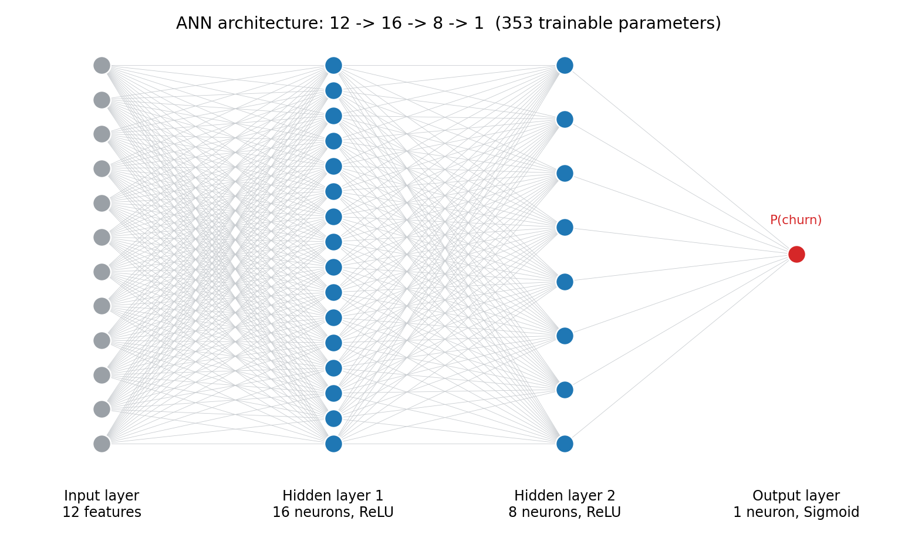
Figure 1. Architecture of the ANN: 12 inputs, 16 and 8 hidden neurons, 1 output neuron.
Layer | Type | Neurons | Activation | Parameters (weights + biases)
Input layer | Input | 12 | None | 0
Hidden layer 1 | Dense | 16 | ReLU | 208 (12 x 16 + 16)
Hidden layer 2 | Dense | 8 | ReLU | 136 (16 x 8 + 8)
Output layer | Dense | 1 | Sigmoid | 9 (8 x 1 + 1)
Total trainable parameters |  |  |  | 353

Why this design
- Two hidden layers narrowing from 16 to 8 neurons. The network compresses 12 inputs step by step into one churn probability, and the non-linear layers can capture combinations such as short tenure together with high monthly charges.
- Small size. With 353 parameters learned from 5,634 customers, the model is compact enough to avoid memorising the training data.
- ReLU activation in the hidden layers. It trains quickly and avoids the vanishing-gradient problem of older activations.
- Sigmoid output. It produces a value between 0 and 1, read as the probability that the customer will churn, which suits a yes/no prediction.
- No dropout layer. Training and validation loss stayed almost identical throughout training (Section 5), so there was no overfitting for dropout to correct. A larger version with dropout was also tested (Section 6).

4. Training Configuration
Setting | Value
Optimiser | Adam (default learning rate 0.001)
Loss function | Binary cross-entropy
Monitoring metric | Accuracy (loss used for early stopping)
Epochs | Up to 50
Batch size | 32
Validation data | 20% of the training set, held out with the churn share preserved (stratified)
Early stopping | Stops if validation loss does not improve for 10 epochs and restores the best weights
Random seed | 42 (results reproducible; 4 further seeds tested for robustness)
Decision threshold | 0.50 by default; 0.39 tuned on the validation set (not the test set) to improve recall
Software | Python, TensorFlow/Keras, scikit-learn

5. Convergence
Convergence was monitored with accuracy and loss curves for both the training data and the held-out validation data.
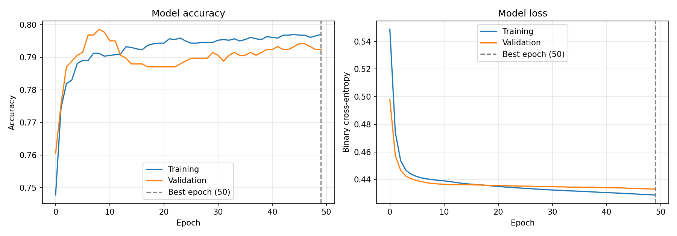
Figure 2. Training and validation accuracy (left) and loss (right) over 50 epochs.
- The loss started at about 0.55 on the training data and 0.50 on the validation data.
- It fell sharply during the first five epochs and flattened at about 0.43 by roughly epoch 15.
- The training and validation curves stayed almost on top of each other, which shows the model learned general patterns and did not overfit.
- Validation loss was still improving by a very small amount at epoch 50, so early stopping did not trigger. The remaining gains were negligible.
Final results. The values below are at epoch 50, the epoch whose weights were kept. The training script saves them in results/training_summary.csv.
Measure | Training | Validation | Test
Loss (binary cross-entropy) | 0.4289 | 0.4331 | 0.4576
Accuracy | 79.7% | 79.2% | 78.2%

6. Comparison With Alternatives
To check that the architecture was a sound choice, it was compared with a larger network that includes dropout and with a simple logistic regression baseline, all trained on the same data and evaluated on the same 1,409 test customers (threshold 0.50).
Model | Accuracy | Precision | Recall | F1 | AUC
ANN 16-8 (selected) | 78.2% | 60.7% | 50.8% | 55.3% | 80.5%
ANN 64-32 with dropout 0.2 | 79.0% | 63.7% | 48.4% | 55.0% | 80.7%
Logistic regression baseline | 79.4% | 65.4% | 47.6% | 55.1% | 80.7%

All three models score within about 0.2 percentage points of each other on AUC. The larger network and the ANN do not outperform the simple baseline, which indicates that the predictive ceiling is set by the information in the available features and not by the size of the network. The compact 16-8 design was therefore selected because it is simpler and matches the submission template, with no loss of performance.

7. Performance and Robustness
Test-set performance of the selected model. The model was applied to the 1,409 unseen customers. The tuned threshold of 0.39 was chosen using validation data only.
Metric | Threshold 0.50 (default) | Threshold 0.39 (tuned)
Accuracy | 78.2% | 76.7%
Precision | 60.7% | 55.2%
Recall | 50.8% | 63.9%
F1 score | 55.3% | 59.2%
AUC-ROC | 80.5% | 80.5%

Lowering the threshold to 0.39 lets the model catch 64% of churners instead of 51%, at the cost of more false alarms (precision falls from 60.7% to 55.2%). When missing a customer who is about to leave is costlier than contacting one who would have stayed, the tuned threshold is the recommended setting.
Robustness. The model was retrained five times with different random seeds. Results were stable: AUC 80.6% (standard deviation 0.1 points), accuracy 78.2% (0.5 points). Recall at the default threshold varied more, at 48.7% (3.2 points), which is another reason to use a tuned threshold in practice.

8. Related Files
File | Purpose
churn_ann_model.h5 | Trained ANN model
churn_prediction.py | Code that builds, trains, evaluates and saves the model
data_preprocessing.py | Reproduces the processed train, test and clustering files from the raw dataset (encoding, 80/20 split, scaling)
results/predictions.csv | Predicted churn probability and class for each test customer
results/training_summary.csv | Final training, validation and test loss and accuracy
results/evaluation_results.csv, results/model_comparison.csv | Performance metrics and model comparison
results/robustness_results.csv | Results for five random seeds
figures/accuracy_loss_graph.png, figures/confusion_matrix.png, figures/roc_curve.png | Training and evaluation charts

